Markov_model_assignment

Kyu Lee; modified by Akash Malhotra

2024-01-28

## In this document, we present the results from Assignment 4 where we conduct a cost-effectiveness analysis considering three strategies: 1) without treatment 2) with treatment but no end-of-life care, 3) with both treatment and end-of-life care. We then provide a table of cost and QALY of three strategies and report ICER for the three 2-way comparisons. The relevant answers are found below under Point #7, and Point #s 10-13. A separate knitted pdf file has also been submitted (it has the code as well).

We have conducted a base case analysis. The structure of our model is as follows: 1. Define fixed variables and parameters for the model 2. Prepare state-specific per-cycle cost, qaly, and transitional cost matrix 3. Prepare transition probability matrix (this will change in simulation given age-specific mortality) 4. Prepare population matrix that keeps track of health state transition by cycle 5. Prepare a matrix (‘trans’) to record the transitional cost 6. Prepare empty matrices to record QALYs and Cost outcomes by cycle and by strategy 7. Define a function to calculate time-dependent transition probability based on age-specific mortality 8. Simulate a cohort for ‘no drug’ and ‘drug’ scenario 9. Calculate cost and qaly of each scenario 10. Calculate ICER 11. Plot

### Basecase analysis

1. Define parameters
2. Prepare cost, qaly, and transitional cost matrix. Note that the parameters defined in the previous block are used/called here cost and qaly matrix has the following structure row: strategies column: health states value: cost, qaly payoffs Transitional cost matrix has the following structure row: health states (departure state) column: health states(arrival state) value: transitional cost(toll)

## Asymptomatic_disease Progressive_disease Dead  
## without_drug 500 3000 0  
## with_drug 1500 3000 0  
## with_drug_eol 2000 3000 0

## Asymptomatic_disease Progressive_disease Dead  
## without_drug 0.95 0.75 0  
## with_drug 0.95 0.75 0  
## with_drug_eol 0.95 0.75 0

## to  
## from Asymptomatic_disease Progressive_disease Dead  
## Asymptomatic_disease 0 0 0  
## Progressive_disease 0 0 1000  
## Dead 0 0 0

1. Prepare transition probability matrix p_matrix is a time-dependent transition probability matrix when incorporating age-specific mortality, meaning that transition probability will depend on the age/cycle. Here we define p_matrix with a set of parameters.

Note: array is useful to create a multidimensional matrix. Here p_matrix has 3-dimensional matrix with (health states x health states) x strategies

## , , = without_drug  
##   
## to  
## from Asymptomatic_disease Progressive_disease Dead  
## Asymptomatic_disease 0.9521 0.0100 0.0379  
## Progressive_disease 0.0000 0.8121 0.1879  
## Dead 0.0000 0.0000 1.0000  
##   
## , , = with_drug  
##   
## to  
## from Asymptomatic_disease Progressive_disease Dead  
## Asymptomatic_disease 0.9571 0.0050 0.0379  
## Progressive_disease 0.0000 0.8121 0.1879  
## Dead 0.0000 0.0000 1.0000  
##   
## , , = with_drug_eol  
##   
## to  
## from Asymptomatic_disease Progressive_disease Dead  
## Asymptomatic_disease 0.9571 0.0050 0.0379  
## Progressive_disease 0.0000 0.8871 0.1129  
## Dead 0.0000 0.0000 1.0000

1. Prepare population matrix that keeps track of health state transition by cycle ‘pop’ matrix will record health state distribution in the population for each cycle by strategy (3-dimensional matrix: (n_states x n_cycles) x n_treatments)

In cycle = 1, everyone is in the asymptomatic disease state. The third dimension is not specified to apply the same operation to both treatment strategies

1. Prepare a matrix (‘trans’) to record total transitional cost per cycle by state ‘pop’ matrix records total number of people in each health state, whereas trans records the number of people who ‘enter’ the state and the cost imposed to those who newly enter the state
2. Define a function to calculate time-dependent transition probability based on age-specific mortality Because non-mortality transition probabilities can change based on mortality, we will update the transition probability matrix given age by calling the following function.
3. The total cost and QALYs for the 3 strategies are provided in the table below

## without_drug with_drug with_drug_eol  
## Costs 9331448.374 16210619.637 21687012.080  
## QALYs 7755.952 8624.738 8993.777

1. The ICER when comparing the 3 strategies 2 at a time are below. The first value is the ICER of the with drug to the without drug strategy. The second ICER is with drug and end of life care compared to the with drug strategy (i.e. if we add end of life care to a with drug strategy at baseline), and the last ICER value is with drug and end of life care compared to without drug.ICER is presented as incremental cost per QALYs ganed.

## 7918.141

## 14839.58

## 9981.667

1. Plot 1: WE see that at a WTP of 20000, the with drug strategy is more cost effective than the without drug strategy (ICER of 7918/QALY gained) 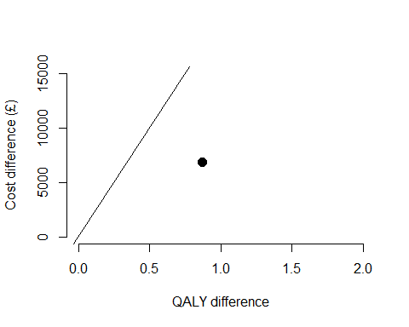

## png   
## 2

1. Plot 2: WE see that at a WTP of 20000, the with drug and end of life care strategy is more cost effective than the with drug strategy (ICER of 14840/QALY gained) 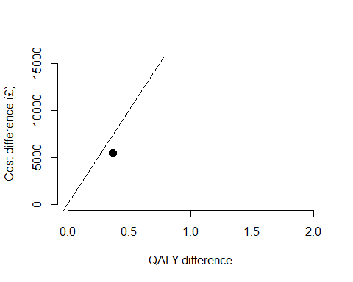

## png   
## 2

1. Plot 3:WE see that at a WTP of 20000, the with drug and end of life care strategy is more cost effective than the with drug strategy (ICER of 9982/QALY gained) 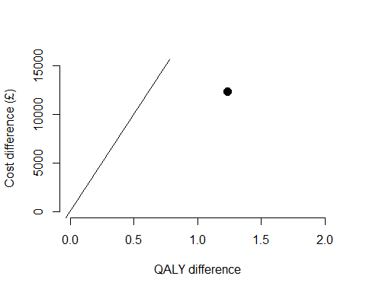

## png   
## 2